# Assignment of

Principles of Navigation

《导航原理》作业

（惯性导航部分 2020春）

|  |  |
| --- | --- |
| My Chinese Name | 尉前进 |
| My Class No. | 1704104 |
| My Student No. | 1170400423 |

The report is to contain:

1. Description of the tasks – the next page.

2. The code of your programs, and their explanation.

3. The results of your computation or simulation (as listed by the requirement).

4. Your analysis of the result, and your reflection on the programming or simulation

5. Originality statements or reference/assistance acknowledgements.

English writing is encouraged, though Chinese is also accepted.

# Assignment 2

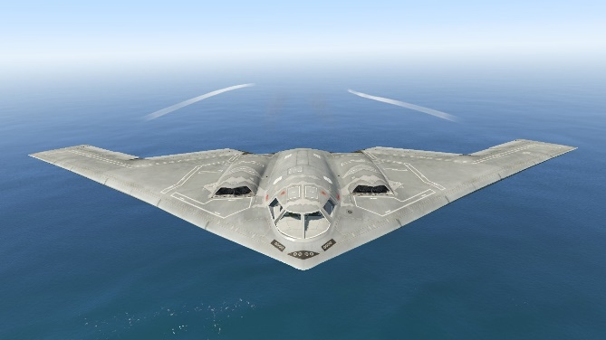In a flight mission, a bomber accelerates and takes off from the runway of an airport located at 24.27o NL and 118.05o EL, which is 120m above the sea level.

Before it accelerates, the bomber stays level on the runway, with only a heading angle of -25o, towards northest.

The bomber is equipped with a strapdown INS whose three gyros, *GX*, *GY*, *GZ*, and three accelerometers, *AX*, *AY*, *AZ*, are installed along the axes *Xb*, *Yb*, *Zb* of its body frame respectively.

The strapdown INS starts to work at the moment the bomber starts its runway acceleration. The outputs of the gyros and accelerometers are both pulse numbers. Each gyro pulse is an angular increment of 0.01 *arcsec*, and each accelerometer pulse is 1e-7*g*0, with *g*0 = 9.780327*m*/*s*2. The gyro output frequency is 500*Hz*, and the accelerometer’s is 25*Hz*. The outputs of the gyros and accelerometers during the flight mission are stored in MATLAB data files named **HB2020.mat**, containing 3-column data arrays ***GMM*** from gyros and ***AMM*** from accelerometers. Ten rows of each array are indicated in the tables, in which each row is the outputs of the sensor at a sampling time.

|  |  |  |  |  |  |  |
| --- | --- | --- | --- | --- | --- | --- |
| *GX* | *GY* | *GZ* |  | *AX* | *AY* | *AZ* |
| 2710 | 5 | 10 |  | -38595 | 1344694 | 9771114 |
| 2710 | 5 | 10 |  | -38647 | 1344601 | 9771045 |
| 2710 | 5 | 10 |  | -38699 | 1344508 | 9770976 |
| 2710 | 5 | 10 |  | -38752 | 1344415 | 9770907 |
| 2710 | 5 | 10 |  | -38804 | 1344322 | 9770838 |
| 2516 | 4 | 20 |  | -38857 | 1344229 | 9770769 |
| 2516 | 4 | 20 |  | -38909 | 1344137 | 9770700 |
| 2516 | 4 | 20 |  | -38962 | 1344044 | 9770631 |
| 2516 | 4 | 20 |  | -39014 | 1343951 | 9770562 |
| 2516 | 4 | 20 |  | -39066 | 1343859 | 9770493 |

The Earth is seen as an ideal sphere, with radius *R* = 6371.00*km* and spinning rate 7.292×10-5 *rad*/*s*, The errors of the gyros and accelerometers are ignored, but the effect of height and latitude on the magnitude of gravity has to be considered. The gravity acceleration can be approximately computed using the formula:



where m/s2,  is the local latitude (rad), and  is the current height above sea level (m).

Besides, the influence of height on the angular rates of the geographical frame and the changing rates of latitude and longitude should also be considered.

Velocity, position and the geographical frame can be updated every 0.04s, within which the attitude of the bomber is to be updated 20 times (for 1-S algorithm).

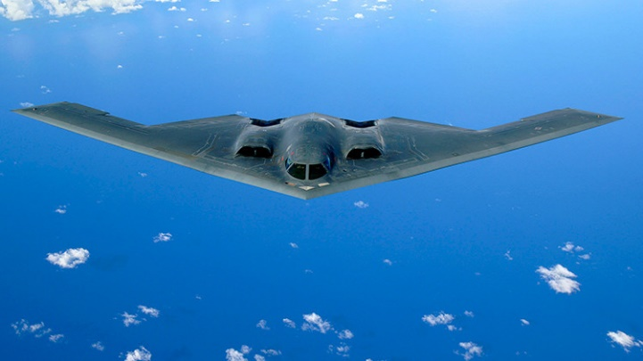You are required to:

(1) Compute the final attitude quaternion, longitude, latitude, height, and east, north, vertical velocities of the bomber.

(2) Draw the latitude-versus-longitude trajectory of the bomber, with horizontal longitude axis.

(3) Draw the curve of the height of the bomber, with horizontal time axis.

(4) Draw the curves of the attitude angles of the bomber, with horizontal time axis.

More analysis or explorations are encouraged.

1. **Analysis**

The initial latitude, longitude, altitude and attitude of the aircraft are known. According to the data measured by the gyroscope and accelerometer, and considering the influence of gravity acceleration and earth rotation, the attitude of the aircraft is updated every 0.002s by quaternion, and the geographic coordinate system is updated every 0.04s. The Picca solution of the angular increment algorithm is approximated by the fourth order, and the influence of altitude and latitude on the gravitational acceleration is taken into account.

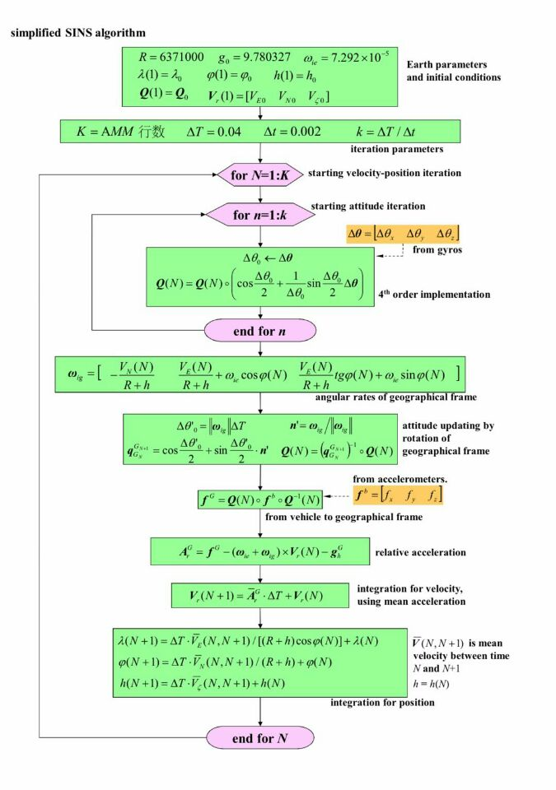

**3.Program Code and Interpretation**

%Data initialization

TN: Total time required for aircraft operation; R: arth radius; wie: Earth rotation angular velocity; dT: the cycle of coordinate updating outer cycle; dt: the cycle of coordinate updating inner cycle; K: the number of updates per second; Gyro_pulse: angular increment of gyro pulse; Acc_pulse: pulse of accelerometer; g: acceleration of gravity on the earth's surface.

%Data initialization

%TN: Total time required for aircraft operation; R: arth radius; wie: Earth rotation angular velocity; dT: the cycle of coordinate updating outer cycle; dt: the cycle of coordinate updating inner cycle; K: the number of updates per second; Gyro_pulse: angular increment of gyro pulse; Acc_pulse: pulse of accelerometer; g: acceleration of gravity on the earth's surface.

TN=7516;

R=6371000;

wie=7.292e-5;

dT=0.04;

dt=0.002;

K= TN /dT;

k=dT/dt;

g=9.780327;

Gyro_pulse=0.01/3600/180*pi;

Acc_pulse=9.780327/10000000;

%Q: Quaternions representing attitude transformation for each large cycle

Q=zeros(K+1,4);

% Quaternion Initial Value

e0=-25*pi/180;

Q(1,:)=[cos(e0/2),0,0,sin(e0/2)];

% Longitudinal, Latitude and Height Values for Each Large Cycle

LonM=zeros(1,K+1);

LatM=zeros(1,K+1);

HtM=zeros(1,K+1);

% Initial value of location information

LonM(1)=118.05;

LatM(1)=24.27;

HtM(1)=120;

% Define the specific force matrix, initial 0

fx=zeros(1,K+1);

fy=zeros(1,K+1);

fz=zeros(1,K+1);

% Define the velocity matrix in all directions, initially 0.

Ve=zeros(1,K+1);

Vn=zeros(1,K+1);

Vu=zeros(1,K+1);

% Define attitude matrix as zero matrix

heading=zeros(615801,1);

pitch=zeros(615801,1);

roll=zeros(615801,1);

% Data measured by loading gyroscope and accelerometer

load('HB2020.mat')

AR0=[0 0 0];

for N=1:K % Geographic coordinate system updating

q=zeros(k+1,4);

q(1,:)=Q(N,:);

for n=1:k % Attitude updating

w=Gyro_pulse*GMM((N-1)*k+n,:); % Take the output angle increment of gyroscope in small cycle

w_mod=norm(w);

S=1/2-w_mod^2/48;

C=1-w_mod^2/8+w_mod^4/384;

q(n+1,:)=quatmultiply( q(n,:),[C S*w] ); % Fourth-Order Approximate Picca Solution of Angular Incremental Algorithms

[h,p,r]=quat2angle(q(n,:)); % Converting Quaternion into Euler Angle by Quadrangle Function

heading((N-1)*k+n,1)=h/pi*180;

pitch((N-1)*k+n,1)=p/pi*180;

roll((N-1)*k+n,1)=r/pi*180;

end % End the Inner Attitude Renewal Cycle

Q(N+1,:)=q(n+1,:); % Quaternion at End of Inner Attitude Updating Cycle

% Perfect the transformation of quaternions into Euler angles

[hn,pn,rn]=quat2angle(Q(K+1,:));

heading(615801,1)=hn/pi*180;

pitch(615801,1)=pn/pi*180;

roll(615801,1)=rn/pi*180;

% Two-step attitude determination in strapdown inertial navigation system

Wie=[0 wie*cos(LatM(N)/180*pi) wie*sin(LatM(N)/180*pi)];

WE=-Vn(N)/(R+HtM(N));

WN=Ve(N)/(R+HtM(N))+wie*cos(LatM(N)/180*pi);

WU=Ve(N)/(R+HtM(N))*tan(LatM(N)/180*pi)+wie*sin(LatM(N)/180*pi);

gh=g*(1+0.0053024*(sin(LatM(N)/180*pi))^2-0.0000058*sin(2*LatM(N)/180*pi)^2)-(3.086e-6)*HtM(N); % Gravity acceleration affected by altitude and latitude

Wig=[WE WN WU];

Wig_mod=norm([WE,WN,WU]);

n=Wig/Wig_mod;

Qg=[cos(Wig_mod*dT/2),sin(Wig_mod*dT/2)*n];

Q(N+1,:)=quatmultiply(quatinv(Qg),Q(N+1,:)); % Quaternions Updated in Geographic Coordinate System

% Take the specific force data measured by accelerometer

fb=Acc_pulse*AMM(N,:);

f1=quatmultiply(Q(N+1,:),[0,fb]);

fg=quatmultiply(f1,quatinv(Q(N+1,:)));

fx(N)=fg(2);

fy(N)=fg(3);

fz(N)=fg(4);

% Compensation for harmful acceleration

AR=[fx(N) fy(N) fz(N)] - cross( Wie+Wig, [Ve(N) Vn(N) Vu(N)]) - [ 0 0 gh];

% Velocity solution

Ve(N+1)=(AR(1)+AR0(1))/2*dT+Ve(N);

Vn(N+1)=(AR(2)+AR0(2))/2*dT+Vn(N);

Vu(N+1)=(AR(3)+AR0(3))/2*dT+Vu(N);

AR0=AR;

% Update location information

LatM(N+1)=(Vn(N)+Vn(N+1))/2*dT/(R+HtM(N))/pi*180+LatM(N);

LonM(N+1)=(Ve(N)+Ve(N+1))/2*dT/((R+HtM(N))*cos(LatM(N)/180*pi))/pi*180+LonM(N);

HtM(N+1)=(Vu(N)+Vu(N+1))/2*dT+HtM(N);

end % End the Outer Geographic Coordinate System Renewal Cycle

HPRatt=[heading,pitch,roll];

% Drawing Longitudinal and Latitude Images

figure(1);

title('Latitude-Lontitude');

xlabel('Latitude');

ylabel('Lontitude');

grid on;

hold on;

plot(LonM,LatM);

% Drawing Height Images

figure(2);

title('height-time');

xlabel('time');

ylabel('height');

grid on;

hold on;

plot((0:K),HtM);

% Drawing Attitude Angle Change Map

figure(3);

plot(heading);

xlabel('time');

ylabel('heading');

title('heading-time');

grid on;

figure(4);

plot(pitch);

xlabel('time');

ylabel('pitching');

title('pitching-time');

grid on;

figure(5);

plot(roll);

xlabel('time');

ylabel('rolling');

title('rolling-time');

% Output final quaternion, velocity in all directions and aircraft position

Q(K+1,:);

LatM(K+1);

LonM(k+1);

HtM(K+1);

Ve(K+1);

Vn(K+1);

Vu(K+1);

save FlightData HPRatt LonM LatM HtM











**4. Key benefits**

This large operation let me know and master the algorithm of SINS, and preliminarily grasp the simulation calculation of SINS with MATLAB, which has further improved the use of MATLAB and benefited a lot.

**5. Job statement**

This assignment refers to YuHan Liu's procedure and got a lot of help from YuHan Liu.